**ASSIGNMENT – 1**

* **Avinash AJ (Reg.No: 211419106037)**

**Question:**

To build a circuit using Tinkercad software, which consists of 2 sensors, 2 led and a buzzer for alarming for the higher values.

**Components List:**

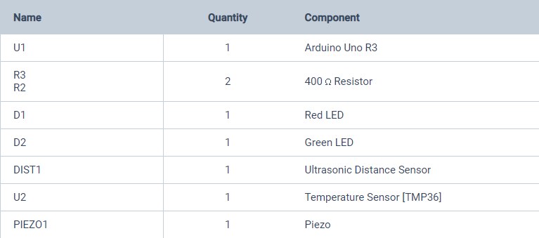

**Circuit:**

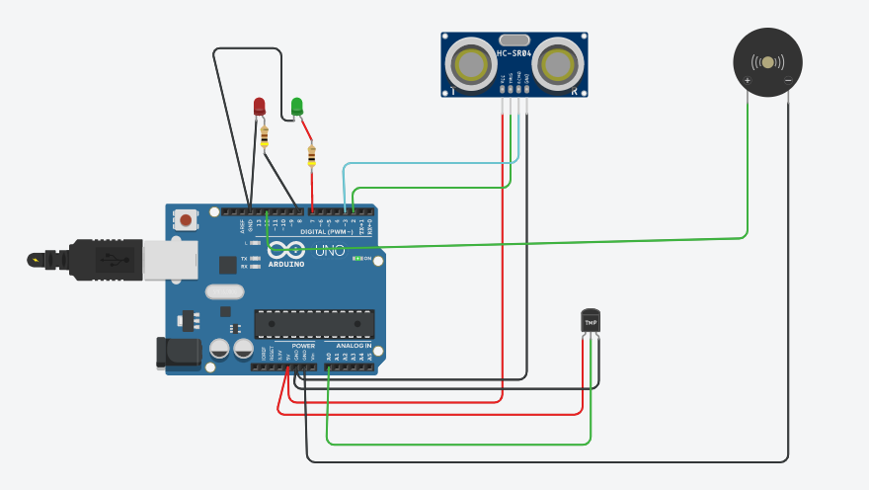

**Code:**

**int t=2;**

**int e=3;**

**void setup()**

**{**

**Serial.begin(9600);**

**pinMode(t,OUTPUT);**

**pinMode(e,INPUT);**

**pinMode(12,OUTPUT);**

**}**

**void loop()**

**{**

**//Temperate Sensor**

**double a= analogRead(A0);**

**double temp=(((a/1024)*5)-0.5)*100;**

**Serial.print("Temp Value: ");**

**Serial.println(temp);**

**delay(1000);**

**//LED ON**

**if(temp>=10)**

**{**

**digitalWrite(7,HIGH);**

**}**

**//Buzzer for Temperature Sensor**

**if(temp>=10)**

**{**

**for(int i=0; i<=30; i=i+10)**

**{**

**tone(12,i);**

**delay(1000);**

**noTone(12);**

**delay(1000);**

**}**

**}**

**//LED OFF**

**if(temp<10)**

**{**

**digitalWrite(7,LOW);**

**}**

**//ultrasonic sensor**

**digitalWrite(t,LOW);**

**digitalWrite(t,HIGH);**

**delayMicroseconds(10);**

**digitalWrite(t,LOW);**

**float dur=pulseIn(e,HIGH);**

**float dis=(dur*0.0343)/2;**

**Serial.print("Distance is: ");**

**Serial.println(dis);**

**//LED ON**

**if(dis>=100)**

**{**

**digitalWrite(8,HIGH);**

**}**

**//Buzzer For ultrasonic Sensor**

**if(dis>=100)**

**{**

**for(int i=0; i<=30; i=i+10)**

**{**

**tone(12,i);**

**delay(1000);**

**noTone(12);**

**delay(1000);**

**}**

**}**

**if(dis<10)**

**{**

**digitalWrite(8,LOW);**

**}**

**}**

**Description:**

**Ultrasonic Sensor**

The led and buzzer is pushed to “HIGH” if the distance is greater than or equal to 100 else the buzzer and led are in “LOW” status.

**Temprature Sensor:**

The led and buzzer is pushed to “HIGH” if the temperature value is greater than or equal to 10 else the buzzer and led are in “LOW” status.

**Output :**

